How to Create a Google Cloud Translation REST API Service:

Steps : Please follow below steps to setup OAuth for Google Translate API.

1. Set-up [google cloud account](https://cloud.google.com/)
2. Enable Google Translation API.  
   Enable the cloud translation API in the [google developer console](https://console.developers.google.com/).

1. Once select the Project . Click on the “Enable APi’s and Services”on the lift side Grid.
2. Then we can able the “+” button with “ENABLE APIS AND SERVICES”. Clck on the button.
3. Once click on the button and search for “cloud translation API” like belowA screenshot of a computer

   Description automatically generated
4. Please click on “Cloud Translation ”API”. We can able to see the “Enable” button.

1. Once we click the “Enable ” button. It will redirect for billing please do complete billing.

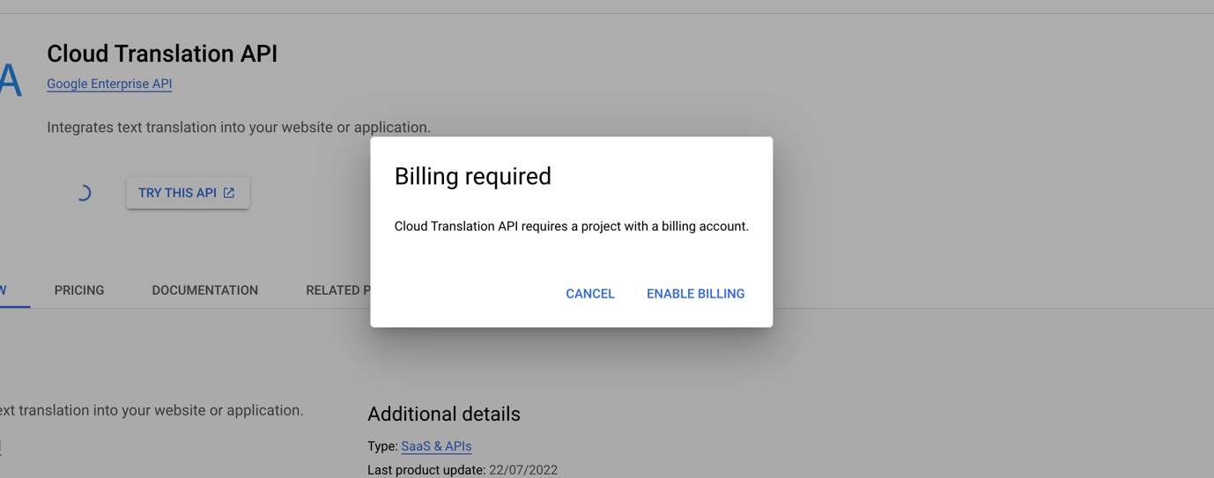

1. Once we are done with billing formalities. Then we are good to go for next steps.
2. Then next navigate to left side bar again and select the “OAuth consent screen”, Tab and we can able the UI like below.

As per the above screens there are couple of mandatory inputs those we have fill  
 🡪 App Name

🡪 User support Email.  
 🡪 Authorised Domain( We can add multiple)

🡪 Developer contact information(email)  
Remains all fields are optional , we can fille based on requirement.

1. Click on “Save and Continue”. Then it will navigate to Scopes tab those are also we can fille based on requirements. And click again Save and Continue so application is saved.
2. Then next navigate to left side bar again and select the “OAuth consent screen”, Tab and we can able the UI like below.

1. Then on the right component please click on the “+ CREATE CREDENTIALS” button. Please select the “oAuth client ID” option.  
   A screenshot of a computer

   Description automatically generated
2. Once click on “oAuth client ID” button. Please select the application type as “web application” from the drop down.
3. A screenshot of a search engine

   Description automatically generated
4. Please select the “application type “ as “web application”.  
   A screenshot of a computer

   Description automatically generated
5. We have the fill the Name option “SmartConx OAuth Stage”. And We can ignore “Authorised JavaScript origins” option because we are utilising this API for Server side not client side.  
   A screenshot of a web page

   Description automatically generated
6. Then we have click on ADD URI option under the “Authorised redirect URIs” and please add two redirect URLS   
   1.

2.

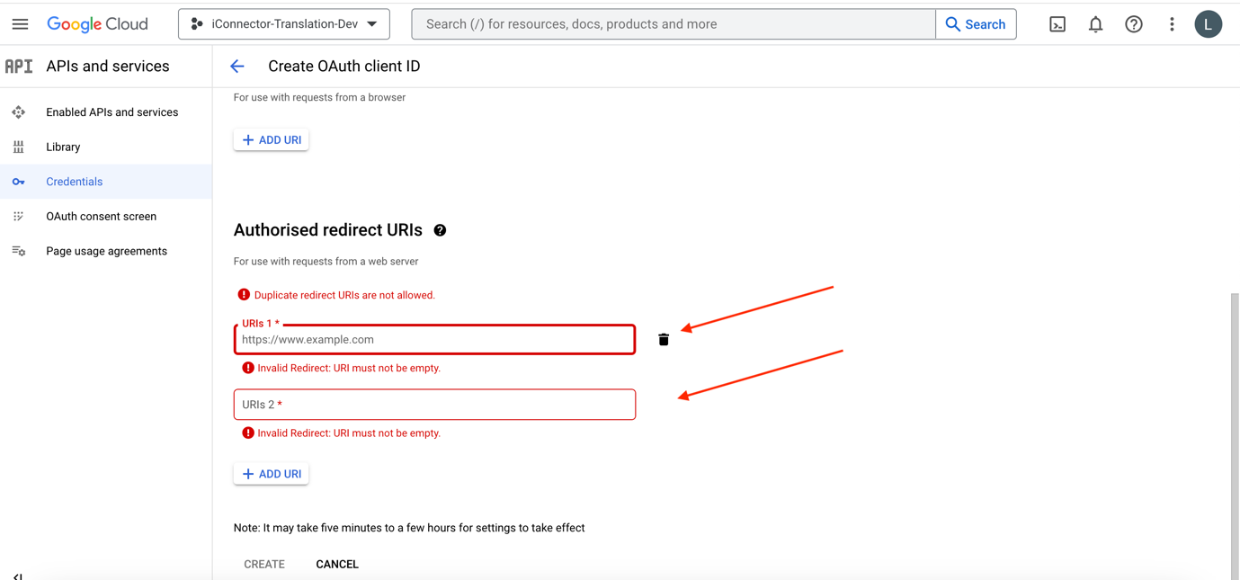

1. Then click on Save Button. Once saved we can able to see a model with oAuth Details and please down load the json file. Saved it for feature utilisation.  
   A screenshot of a computer

   Description automatically generated
2. Then we have to Generate the Access token and Refresh Token so please go to [“Google Play Ground”](https://developers.google.com/oauthplayground)
3. Once Navigated to Play Ground. Navigate to right top corner gear icon  .

1. Once Enter in to Options. Please Enable the check mark “Use your own oAuth Credentials”. It will show the two properties Oauth client ID and OAuth clinet secret please fill the datails which is from the downloaded json file on the step no : 16.

1. Once close the window. Left Bread Crem select the Step 1 “Select & Autherised API’s” option. Please select the “Cloud Translation API V3” both options.  
   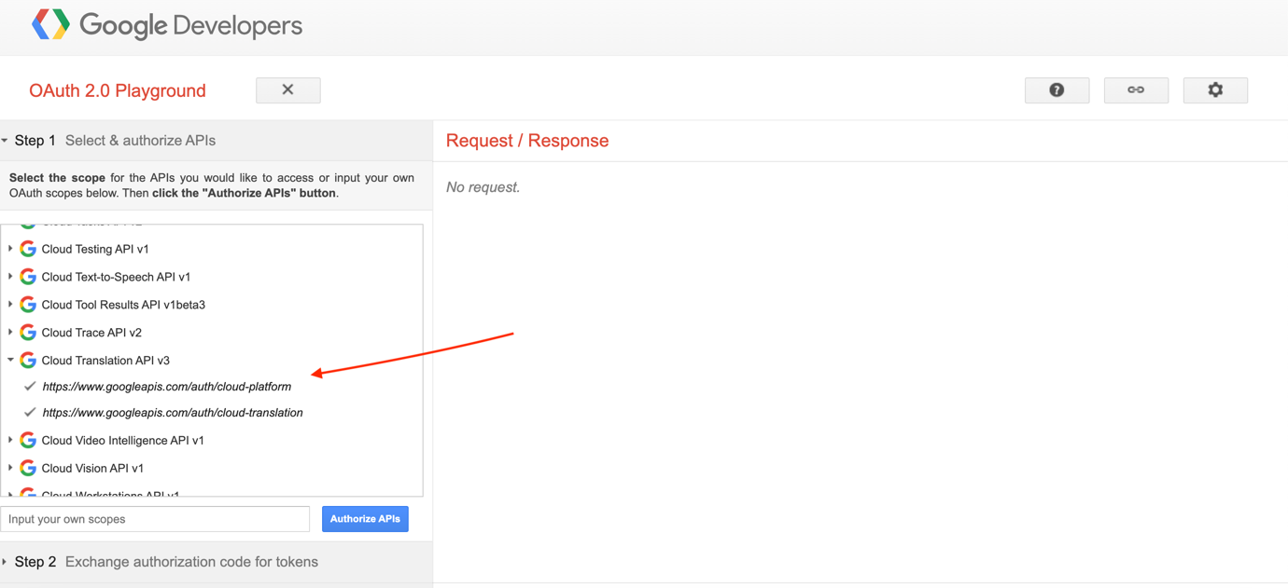
2. Once selection done. Click on “Authorize APIs” option.  
   A screenshot of a computer

   Description automatically generated
3. Once click on “Autherise apis ” button it will redirect for authentication. Please enter username and password of the google account.  
   A screenshot of a computer

   Description automatically generated
4. Then it will ask for allow permissions. Please click the Allow  
   A screenshot of a computer

   Description automatically generated
5. Once we are allowed it will redirect back to same page of play ground.
6. Then we are able to see oAuth code was generated.
7. Click on “Auto-Refresh the token before it expires” check box.

1. With that code we have to generate the access token and refresh Token . so for that please click on the “Exchange authorizationcode for tokens” button.  
   A screenshot of a computer

   Description automatically generated
2. Then Please collect the access token and Refresh Token for API use.

1. Finally to check the tokens are working or not we have to an API for translation.
2. Open post man and paste below curl request.

curl --location 'https://translate.googleapis.com/v3/projects/iconnector-translation-dev:translateText' \

--header 'Authorization: Bearer ya29' \

--header 'Content-Type: application/json' \

--data '{

"contents": [

"Text message"

],

"mimeType": "text/html",

"targetLanguageCode": "es"

}'

1. Replace the project and access token and try It has to return 200 response.  
     
   Thank you